Stardew Valley Bundle Manager

Brittney MacLennan

University of Missouri – Kansas City

Table of Contents

Vision Statement 3

Requirements 4

Product Backlog 5

Sprint #1 6

Review 6

Retrospective 6

Sprint #2 7

Review 7

Retrospective 7

Sprint #3 8

Review 8

Retrospective 8

Sprint #4 9

Review 9

Retrospective 9

Sprint #5 10

Review 10

Retrospective 10

Sprint #6 11

Review 11

Retrospective 11

# **Vision Statement**

With this project, I am aiming to create an app that will help players of the game *Stardew Valley* be able to track “bundles” from the Community Center in their game. These bundles are made up of various items that will unlock rewards when all of them are collected. The key features of this app will consist of a list that will allow users to keep track of what items they have already found and what items they still need to collect.

The reason for creating this app is because I have often found myself wondering what items I still need to collect for the Community Center when I am playing the game, but the only way to see what items are still required is to go to the Community Center in the game which can take time away from other tasks depending on where you are on the map. My hope is that this app will prove useful to players as they will no longer have to go into town to check their progress and instead be able to check their phone and continue working on their other goals.

Depending on how difficult coding proves to be, the immediate release will be a barebone list that syncs to a database so that user progress is saved when the app is closed. Users will be able to click on the items under the bundle types to mark them as collected. If the coding is not too difficult, I would like to make the menu more aesthetically pleasing by adding images from the game and making a user interface that resembles what is seen in the game.

Stretch goals consist of allowing users to have multiple trackers going for different characters as users can create multiple characters in the game. Another stretch goal is to allow the switching of menu types between an image-based UI compared to a text-only IU for those that have a preference between the two.

# **Requirements**

A discussion of what your application is required to have in functionality. It should identify user roles and goals/actions, and what the key features of the app should be.

|  |  |
| --- | --- |
| **Actor** | **Goal** |
| Users | Want an app that looks nice and is easy to use. |
| Users | Want their choices to persist after the app is closed. |
| Users | Would like to track bundles over multiple characters. |
| Users | May enjoy the ability to switch between compact and non-compact UI. |
| Team Lead | Wants the app to be shared by word of mouth by happy users. |
| Team Lead | Wants to create an app that users will use over similar apps. |
| Team Lead | Wants to create a project they themselves would use. |
|  |  |
|  |  |
|  |  |
|  |  |
|  |  |
|  |  |
|  |  |
|  |  |

### Product Backlog

This will be updated throughout the semester as new PBIs are added, larger items are broken into smaller ones, and completed items removed.

|  |  |  |  |  |
| --- | --- | --- | --- | --- |
| **Story ID** | **Story** | **Story Points**  **(in est. hours)** | **Priority** | **Status** |
| 1 | Background | 2 | 2 | Complete |
| 2 | Logo | 2 | 2 | Complete |
| 3 | Title Screen | 3 | 1 | Complete |
| 4 | User Interface | 4 | 1 | Complete |
| 5 | List Layout | 4 | 1 | Complete |
| 6 | Interactable List | 6 | 1 | Complete |
| 7 | Create SharedPreferences File to Save Choices | 5 | 1 | Complete |
| 8 | Create image-based UI for list | 8 | 3 | Complete |
| 9 | Allow users to track multiple bundles | 10 | 4 | In Progress |

# **Sprint #1**

Sprint Backlog

|  |  |  |  |
| --- | --- | --- | --- |
| **Story ID** | **Story / Task** | **Estimated**  **Hours** | **Actual**  **Hours** |
| 1 | Background | 2 | 1.5 |
| 2 | Logo | 2 | 1.5 |
| 3 | Title Screen | 3 | 2 |
|  |  |  |  |
|  |  |  |  |
|  |  |  |  |
|  |  |  |  |

## 

## Review

|  |  |
| --- | --- |
|  | The first sprint was spent designing a startup screen for the app that looked aesthetically pleasing and fit with the theme of the game. I feel that this was accomplished, though the buttons currently on the screen are subject to change depending on how future sprint goes and whether multiple bundles will be possible. Everything planned for this sprint was accomplished. |

## 

## Retrospective

I believe that I played this sprint relatively safe and that I could have combined the goals I initially made for spring 2 into the first sprint as well. However, my time management for this sprint went well and that is something I would like to carry into spring 2, especially since I think spring 2 will be where the project will start to become challenging. I think going into the future sprints that I will plan to do more rather than less and if those goals are not accomplished add them to the Product Back Log instead of feeling like I failed by not finishing them during the sprint.

# **Sprint #2**

Sprint Backlog

|  |  |  |  |
| --- | --- | --- | --- |
| **Story ID** | **Story / Task** | **Estimated**  **Hours** | **Actual**  **Hours** |
| 4 | User Interface | 4 | 4 |
| 5 | List Layout | 4 | 3.5 |
|  |  |  |  |
|  |  |  |  |
|  |  |  |  |
|  |  |  |  |
|  |  |  |  |

## Review

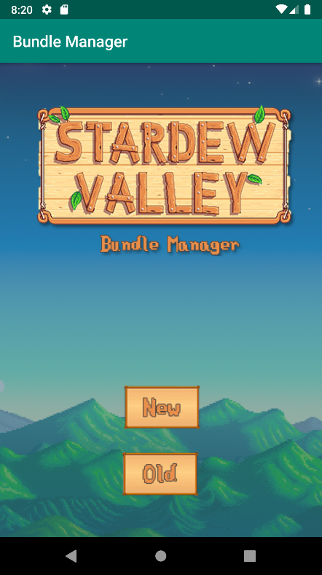 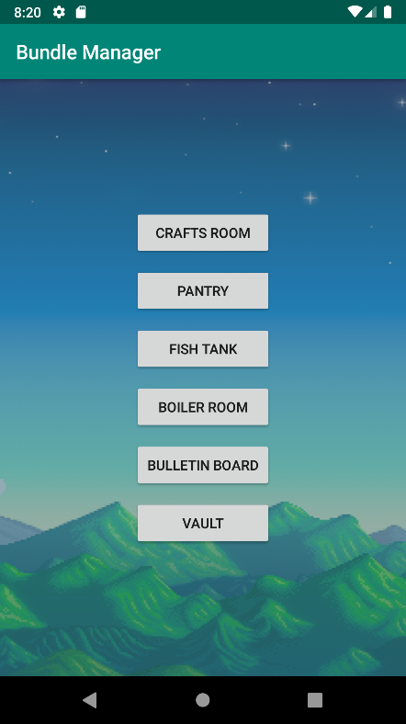 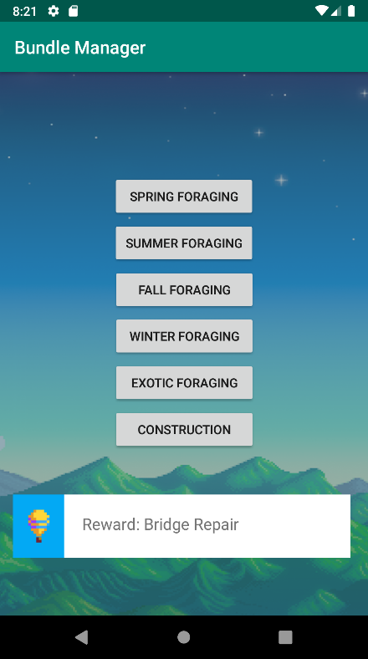

The user interface was designed during this sprint, and a bare bones layout for the list items was made. Once the user interface was designed, it was easy to begin to implement what the list would look like. Because I wasn’t certain just how different the user interface and the list layout would be, I estimated them as two separate tasks when they really went together very well. Most of the time for the tasks were spent doing tedious work instead of anything that was particularly challenging. Every button in the second screenshot opens a new activity, which looks like the third screenshot.

## Retrospective

I still view these tasks are relatively “safe” and except them to become more intense starting with the third sprint. Ideally, I would like to make the plain buttons in the screen shots above to be a similar style to the “new” and “old” buttons on the title screen, but I believe that is a project that can wait until later. The time calculations for the sprint include researching different methods for the lists as well as implementing actual code.

In the next sprint I’m going to start making a list that users can interact with. My primary goal for the third sprint is to make the list interactable first, then make it look good second. If there is time, I may begin researching into a client side database so that choices the users make will persist after the app has been closed instead of waiting for the fourth sprint since I have estimated the database to be a rather daunting and challenging part of spring four.

# **Sprint #3**

Sprint Backlog

|  |  |  |  |
| --- | --- | --- | --- |
| **Story ID** | **Story / Task** | **Estimated**  **Hours** | **Actual**  **Hours** |
| 6 | Interactable List | 6 | 3 |
|  |  |  |  |
|  |  |  |  |
|  |  |  |  |
|  |  |  |  |
|  |  |  |  |
|  |  |  |  |

## Review

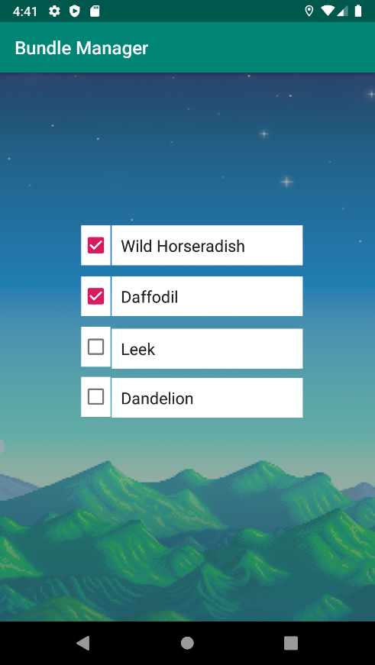

This is perhaps the most important part of this project, as users will need to be able to interact with the options for the bundle choices otherwise the app would be useless. Currently, the layout is very simple and consists of a checkbox that users can toggle to show if they have completed the option or not. However, time permitting, there is an option for a later sprint to make the UI image based and more aesthetically pleasing.

## Retrospective

The reason that the estimated hours for this project were so high in the beginning is because I wasn’t sure how easily I would be able to implement the interactable list. Thankfully, it proved to be simpler than I anticipated. However, there are a lot of lists that need to be implemented and thus it will still take some time to get all the bundle options completed in the app. Also, the constraints are slightly off and things aren’t lined up exactly how I would like but I will fix that for the next sprint.

I didn’t accomplish as much as I would have liked this sprint because of the current social climate. I’m struggling with drive and motivation as well as mental health, but I am going to put in my best effort. I’m uncertain whether this belongs under the retrospective, but I wanted to include it.

# **Sprint #4**

Sprint Backlog

|  |  |  |  |
| --- | --- | --- | --- |
| **Story ID** | **Story / Task** | **Estimated**  **Hours** | **Actual**  **Hours** |
| 7 | Create SharedPreferences File to Save Choices | 5 | 5 |
|  |  |  |  |
|  |  |  |  |
|  |  |  |  |
|  |  |  |  |
|  |  |  |  |

## Review

My original plan for the project was to create a SQLite database that would save user choices to a database that could be pulled up later. However, the more I began to research the more I realized that an SQLite database may not be the best fit for my project. Based on research, I decided to go with Android’s built in SharedPreferences and keep the choices locally on the device in a file that couldn’t be edited by other apps.

I do not have a screenshot for the project because the screenshot would be the same as the last iteration, but I did create a video that can be viewed [here](https://imgur.com/4fhIVpX). This video is also included in the GitHub repo.

## Retrospective

I think this sprint went well even though I changed my mind through the sprint on what was to be accomplished. I was able to still deliver the same desired effect through a different method, and my research taught me that the initial idea I had to handle storing user choices may not be the best fit for the project. I think the next sprint is going to be a challenging one, and it was originally intended as a stretch goal. I may need to reevaluate how to handle future sprints as we near the end of the semester. I have updated the project backlog to reflect the changes I made for this iteration during this sprint.

# **Sprint #5**

Sprint Backlog

|  |  |  |  |
| --- | --- | --- | --- |
| **Story ID** | **Story / Task** | **Estimated**  **Hours** | **Actual**  **Hours** |
| 9 | Create image-based UI for list | 8 | 6 |
|  |  |  |  |
|  |  |  |  |
|  |  |  |  |
|  |  |  |  |
|  |  |  |  |
|  |  |  |  |

## Review

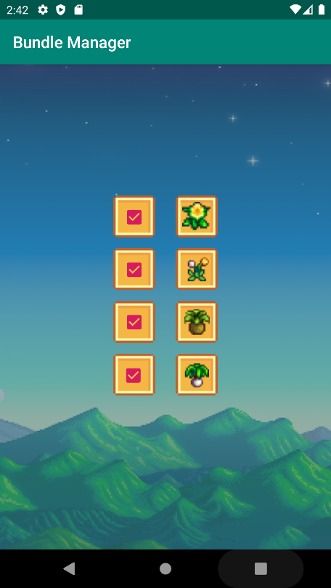

Thankfully, I was able to complete everything I wanted to accomplish for this sprint, though the sprint itself proved to be more tedious than the others as I had to find the correct images and then make sure they were resized how I wanted them. The task wasn’t difficult, but it was time consuming, as each bundle has different items within it meaning that many images had to be collected. I’ve attached a screenshot of one of the bundles to show how the interface has gone from text-based to image-based.

## Retrospective

As I stated before, I was thankfully able to accomplish everything that I wanted to in this sprint. However, the one thing that I want to look into changing going forward is finding a way to make it so the checkboxes aren’t that blindly pink color that they are presently. Unfortunately, looking ahead to the next sprint, I am uncertain whether or not I will be able to allow users to check multiple bundles. This is something that I will evaluate going forward and research before starting the next sprint, but given the way I save user choices at the moment, I am uncertain that multiple bundles will be possible.

# **Sprint #6**

Sprint Backlog

|  |  |  |  |
| --- | --- | --- | --- |
| **Story ID** | **Story / Task** | **Estimated**  **Hours** | **Actual**  **Hours** |
| 10 | Allow users to track multiple bundles | 10 |  |
|  |  |  |  |
|  |  |  |  |
|  |  |  |  |
|  |  |  |  |
|  |  |  |  |
|  |  |  |  |

## Review

[Screenshots, etc go here. This is where you discuss the product, describing what was done this sprint (potentially shippable product increment) and what was planned for the sprint but was not done. ]

## Retrospective

[This is where you discuss the process. What went well (and are you planning to do more of that?) What didn’t go so well (and do you have a way to do less of that)? What changes are you planning to make in how you plan & carry out the next sprint?]